DOKUZ EYLUL UNIVERCITY

Faculty of Engineering

Electrical and Electronics Engineering

**EED 1005 Introduction to Programming Laboratoary#8**

Student Name : Yavuz BALI Experiment Date: December 18,2016

Number:2014502021

**Preliminary Work:**

**TASK 1:**

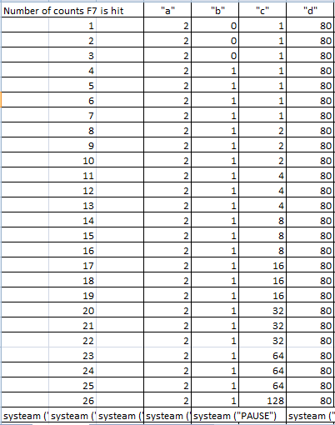

**TASK 2:**

#include <stdio.h>

#include<stdlib.h>

int main (void)

{

int exp,base;

int product=1,i;

printf("Enter integer base and exponent: ");// don't forget semicolon

scanf("%d%d", &base,&exp);

for (i=1;i<=exp;i++)/* if "i" do not increase in loop,loop goes ferevers

and must be "i<=exp"*/

{

product *= base;

}

printf ("%d to the power %d is: %d\n",base,exp,product);

system("PAUSE");

return 0;

} 